BLUETOOTH AND ARDUINO BASED SMART HOME
SYSTEM USING VOICE COMMANDS

ABSTRACT:
Automation is a trending topic in the 21st century making it play an important role in our daily lives. The main attraction of any automated system is reducing human labour, effort, time and errors due to human negligence. With the development of modern technology, smart phones have become a necessity for every person on this planet.Another upcoming technology is natural language processing which enables us to command and control things with our voice. Combining all of these, our paper presents a micro controller based voice controlled home automation system using smartphones. Such a system will enable users to have control over every appliance in his/her home with their voice.

OBJECTIVE:
A Microcontroller based voice controlled home automation system
using smartphones is the main objective of this project.

WORKING PRINCIPLE:
The control circuit consists of an Arduino Uno microcontroller, which processes the user commands and controls the switching of devices. The connection between the microcontroller and the smartphone is established via Bluetooth, a widespread wireless technology used for sharing data.

WORKING MECHANISM:
we implement our system on a bread board. The microcontroller device with the Bluetooth module and relay circuit needs to be attached with the switch board. Then we need to launch the android based application “AMR” on our smartphone. Through the application we can instruct the microcontroller to switch on/off an appliance. After getting the instruction through the Bluetooth module the microcontroller gives the signal to the Relay board.
The application first searches for the Bluetooth device. If it is available then it launches the voice recognizer. It reads the voice and converts the audio signal into a string. It produces a value for each appliance which will be given to the Microcontroller device. The microcontroller uses the port in serial mode. After reading the data it decodes the input value and sends a signal to the parallel port through which the relay circuit will be activated.

BLOCK DIAGRAM:

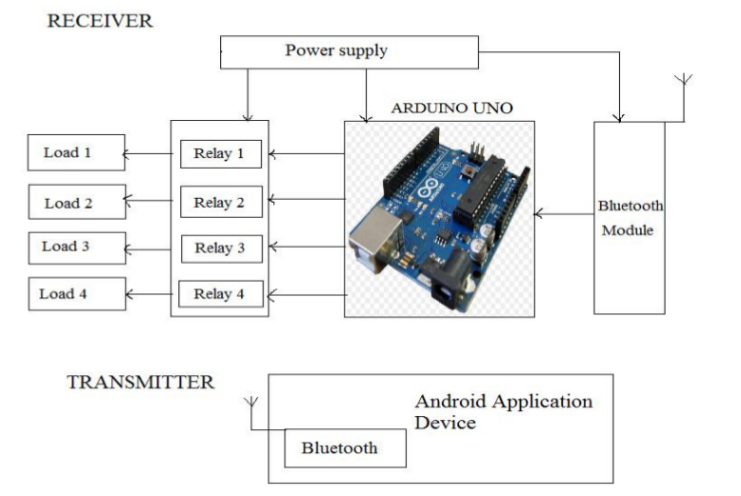
ADVANTAGES:
- This project can provide the facility of monitoring all the appliances with in the communication range through bluetooth
- All the control would be in our handsby using the home automatic system
DISADVANTAGES:
- When the new users want to connect,first download application software and then configuration must be done
- Bluetooth used in this home automation system,which have a range of 10 to 20 meters only.
- Pronounciation of the user when doing the process.

CHALLENGES FACED:
We need to be careful with the relay module while giving connections.Command should be flexible to pronounce so that the application can able to read it easily.

APPLICATIONS:
We can also implement in industrial fields and in various domains.

CONCLUSION:
We can connect IoT kits like raspberrypi to connect to operate through the internet to make life easier.

COST OF THE PROJECT: 1500/-

